CALL FOR ART
BOISE AIRPORT WALL SURFACE 3-D PUBLIC ART
DEADLINE: Friday, February 13, 1:00pm MT
ARTIST BUDGET: $50,000
LOCATION: Boise Airport, 3201 W Airport Way #1000, Boise, Idaho 83705
INFO-SESSION: January 28 at 12:00pm (MT) LINK HERE

Opportunity
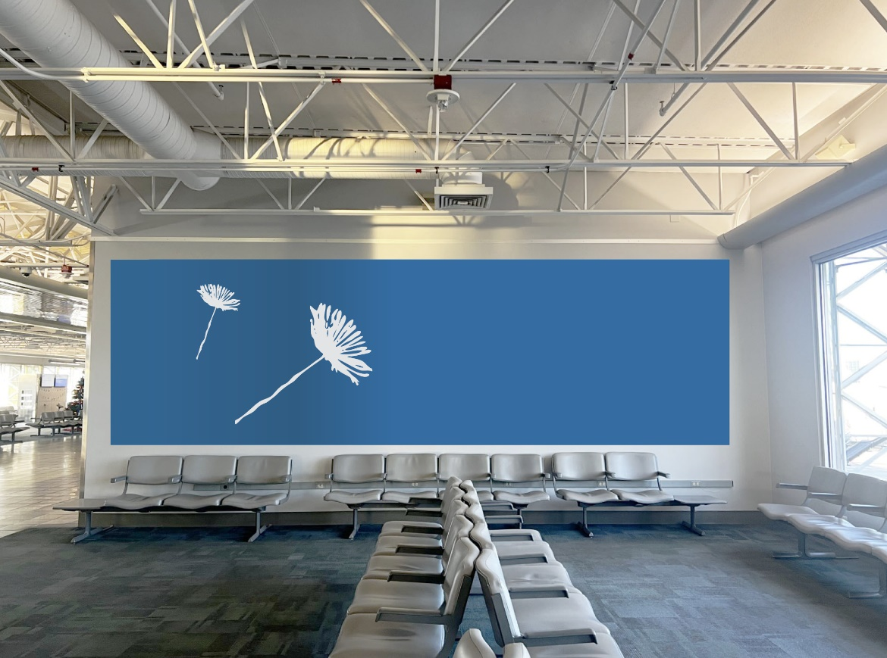
The City of Boise’s Department of Arts & History and Boise Airport invite artists and artist teams to submit qualifications for the opportunity to design a new 3-Dimensional work of art to be installed in the Boise Airport. The selected artist(s) will be awarded $50,000 to design, fabricate, and install a surface-based 3-Dimensional work of art on a flat, vertical wall. The wall is located next to Gate 18 of Concourse B in the Boise Airport (see image).

This opportunity will follow a hybrid RFQ/RFP application process, beginning with a Request for Qualifications (RFQ) followed by a Request for Proposals (RFP). The Request for Qualifications will result in up to three finalists being invited to submit proposals for a $500 stipend. Any use of AI generated artwork or ideas must be notated in your proposal, at what point AI was used, and detail the nature of the use

A “surface-based 3-Dimensional installation” artwork can be any 3-Dimensional work of art that can be installed directly onto a flat, vertical wall. This may include (but is not limited to) textiles, mosaics or tile wall hangings, mixed media, nontraditional compositions of traditional materials, and relief or wall-mounted sculptural works. The work must be under 4 inches in depth and weigh less than 400 lbs. The artwork must be modular to support future relocation and installation in different locations and compositions.

Project Background and Goals
Boise’s landscape is often portrayed as idealized, with images of the city and surrounding natural environment seen through rose-colored glasses. Boise is becoming a city that feels both familiar and foreign, solid and surreal. Many buildings and streetscapes no longer look the way they did decades ago, and many plots that served as farmland are being traded for urban development. As the United States and its cities have evolved over time, there has been a stretch between rural life and urbanization, tradition and modernity. While this forward momentum is welcomed, it also harbors a longing for the past, leaving residents with mixed feelings towards change.

Project Goals:
- Use shifting narratives towards progress and nostalgia as inspiration to inform the design of a new piece of public art.
- Evoke nostalgia against the backdrop of a rapidly shifting city.

Location and Logistics
This call requires artists to consider multiple factors:
- Potential artwork must be 3-Dimensional. For this call, we are not seeking traditional works of art such as framed prints or paintings.
- Potential artwork must be of modular and adaptable design.
Selected finalists will be asked to consider the following additional factors:
- Potential artwork may not exceed 400 lbs. including installation hardware.
- Potential artwork may not exceed more than 4” in depth, meaning it cannot protrude more than 4” off the wall.
- The work will be installed on a wall by Gate 18 in Concourse B of the Boise Airport. The available space for artwork on the wall is approximately 22 feet long by 5 ½ feet tall.
- The selected artist(s) will meet with A&H and Boise Airport staff to discuss specific dimensions, security requirements, and installation logistics.

Anticipated Project Timeline
Description | Date
Call to Artists released | January 13, 2026
Application Info-Session (recording will be posted online) | January 28, 2026, at 12:00 pm MT  zoom registration link
Questions & clarifications due via email | February 11, 2026, at 5:00 pm MT
Application deadline | February 13, 2026, at 1:00 pm MT
Finalists Selected | February – March 2026
Finalists work on proposals | March 2026
Artist Selected | April - May 2026
Contracting and scheduling | May - June 2026
Preliminary design due | August 2026
Final Design Delivery and Review | September 2026
Fabrication of Artwork | Fall 2026
Delivery of Finished Work for Installation | Winter 2026
Installation | Winter 2026 – Spring 2027
Closeout | Summer 2027
This timeline is intended to provide applicants a loose framework for project phase expectations. The timeline is subject to change based on the approval process and needs of the overall project.

Budget
The selected artist(s) will be awarded a $50,000 contract to collaborate with the project team, schedule and coordinate fabrication of the artwork, and deliver the artwork for installation. The selected artist(s) will be responsible for any and all costs necessary to complete their scope of work including but not limited to any materials, fees, and related travel. Project administration and installation will be coordinated, managed, and paid for separately by the City of Boise for a combined project total of $70,400.

Application Requirements
You can access the application by clicking this link:
Surface-Based 3-D Installation Application

Online applications must be submitted through “Submittable” which allows free submissions and uniform review. Limit ONE submission per artist or artist team. Incomplete applications will not be considered. The online application form requires the following information:
- Eligibility
Artist teams with a variety of mediums are strongly encouraged to apply. Local artists are strongly encouraged to apply. Applicants must be 18 years or older. Artist teams should only submit ONE application per team.

- Initial Application Questions
Complete the online initial application questions. These initial questions require basic information including name, address, contact information, etc.
- Artist Resume (upload)
Upload a current artist resume. Include any websites or social media accounts relevant to your work as an artist.
- Written Statement (upload/type 250 words or less, or video under 2 mins.)
Respond to the project goals in your written statement.
- Concept Description (upload/type, 500 words or less, video under 3 mins.)
Please describe your intended concept in writing. Selected finalists will be compensated for a rough visual proposal.
- Proposed 3D medium (two past work examples must match your proposed medium).
  - Includes preliminary ideas for modular capability.
- Briefly describe connection between your proposed medium and intended concept to the project goals, including nostalgia.
- Previous Work Examples (upload)
Provide three images of three different previous work samples that demonstrate your ability to meet the defined project opportunity. The selection panel will use these examples to better understand the potential of your concept. Work samples should not include your proposed concept. Past work examples must include at least two examples that are consistent with material, quality, and aesthetic of proposed artwork. Images are to be in JPEG format, at least 300 dpi.

- Optional: Demographic Information (type)
Please describe how you identify (this can include race, gender, cultural background, sexuality, ethnicity, disability, etc.)

Selection Criteria and Process
We encourage innovative ideas and diverse use of media/materials. Criteria for scoring submissions may include, but are not limited to:
- Eligibility, application completion (Pass/Fail)
- Appropriate medium (Pass/Fail)
  - At least one previous work example must be consistent with proposed medium listed in concept description.
- Artistic quality of previous work examples
- Evidence of ability to follow-through and meet deadlines
- Efficacy of written statement in addressing project goals
- Concept description includes required themes
  - Potential art is a 3-Dimensional medium, includes ideas for modular capability, and addresses nostalgia.

Artists will be selected by a selection panel, a group that may consist of project and community stakeholders, an Arts & History Commissioner, an Airport Commissioner, and a local artist. Selection panelists may give preference to artists that are not currently represented in the Public Art Collection.

Questions & clarifications must be submitted to Savannah Shaon sshaon@cityofboise.org, by Wednesday, February 11, 2026.

Applications are due by Friday, February 13, at 1:00 pm MT.

Diversity, Equity, Inclusion & Belonging
The City of Boise is proud to be a welcoming community striving to ensure a safe, equitable, and inclusive city that celebrates the diversity of people who live, work, and play in our community and recognizes the fundamental human dignity of all. In our commitment to engaging everyone, the City of Boise is actively removing barriers to participation, including for our residents with disabilities and those who prefer a language other than English. If you need an accommodation to access City of Boise’s services, programs, or activities, please contact us at artsandhistory@cityofboise.org or 208-972-8500 (TTY 711).

